# Page Functionality

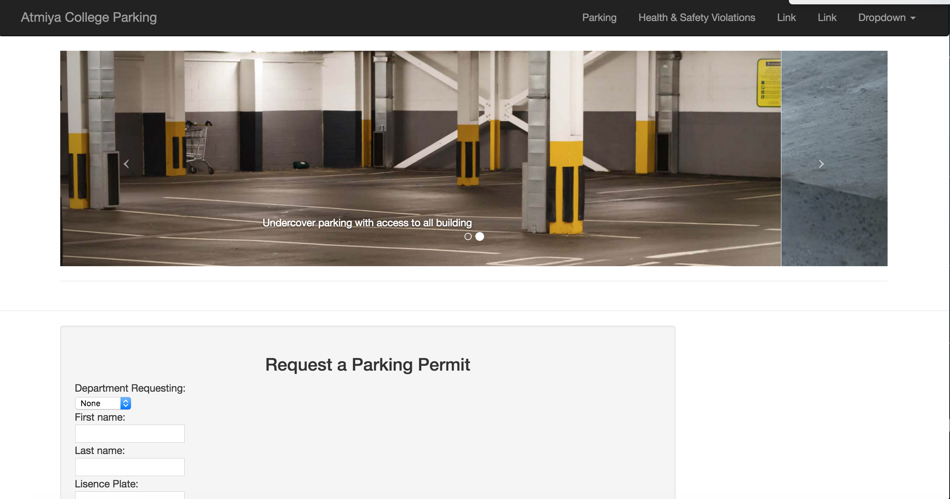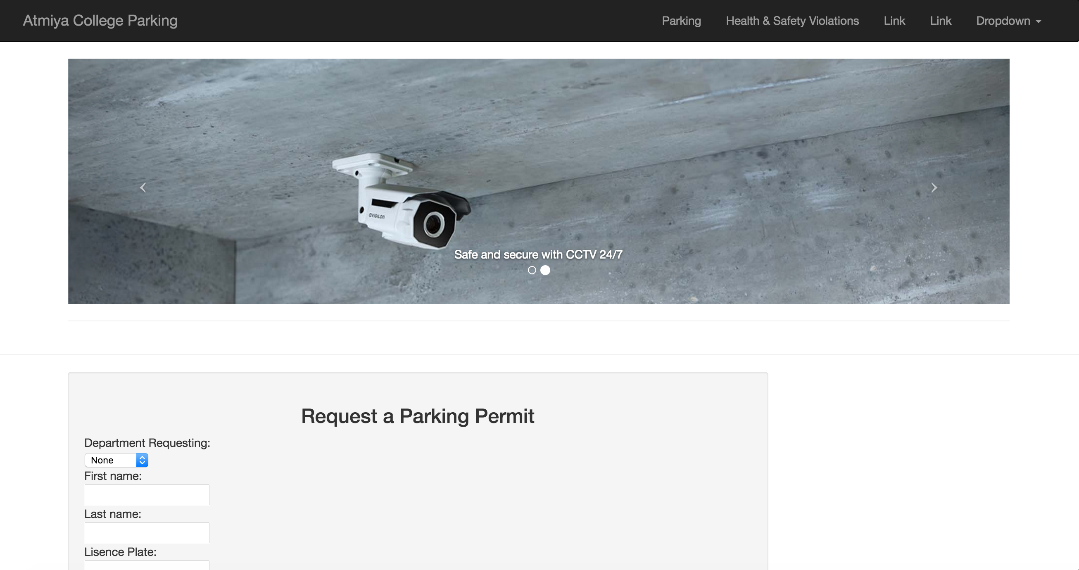

the image in container below the navigation bar can be changed both automatically or manually click the arrow on the side of the image

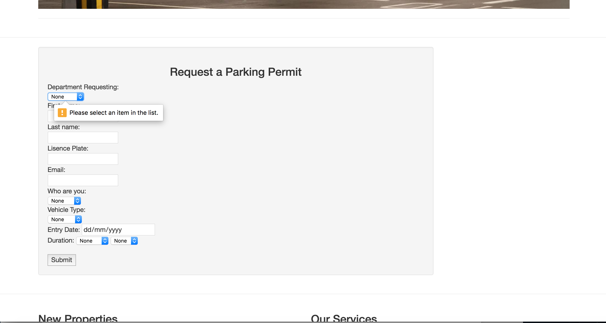

every required textbox will need to be fill out, otherwise there will be a pop-up message to notice user that the blank needs to be filled out.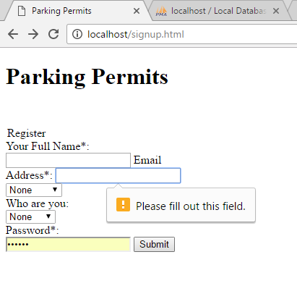

the register page has the same pop-up feature to notice users there are blanks in form as well.



By clicking the buttons in the top navigation bar, users can be directing to the page they want and it is worked for the parking page and health & Safety page only for now.

# Database functionality

The database used for now is called PHPMyAdmin

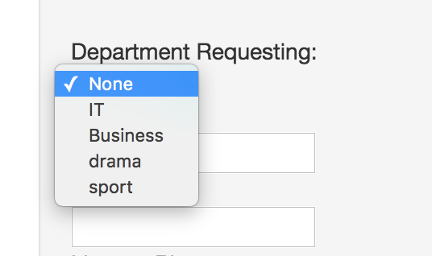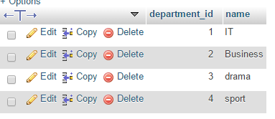

The department of requesting has prefilled into database, so it is easier to collect information from different department by using department id to locate a specific department.

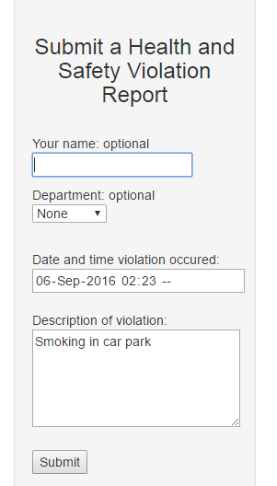/Users/Sam/Downloads/screen captures/health violation database.PNG

the health violation form test, leave the optional part as blank and fill everything else in, and the report did show in the database, the optional part is null and things filled in record correctly.

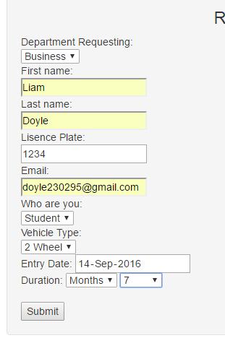

parking permit form test, after filling in everything and submit. The information successfully writes into database, and the department transferred into the department id it has.

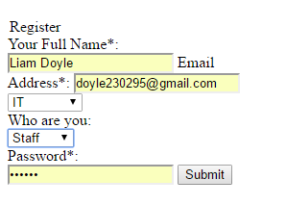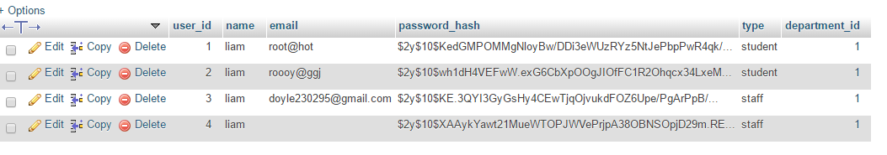

after correctly fill in the registration form, the detailed information can be input into the database. There are couples of user register test. The password for users will be hashed for the better security.